1. **Introduction** 
   1. **Background**

With the advancement of technology, the world has shifted online, and e-commerce has become a dominant force. As people’s lives grow busier, online shopping has risen in popularity, offering convenience and comfort, and its growth shows no signs of slowing down. Consumers are no longer limited to local products or shops; they now seek unique and diverse products from around the world. E-commerce has made this possible, eliminating the need to travel long distances to purchase items. Instead, people can simply browse online, select their desired products, and have them delivered to their doorstep. This technological progress has also boosted the production and availability of goods and services worldwide.

Recognizing this trend, our team developed *Shikali Threads*– an e-commerce platform dedicated to showcasing and sharing the rich cultural heritage of Nepal. With 125 distinct ethnic groups and cultures, Nepal boasts a wealth of unique traditions and attire. *Shikali Threads* aims to bring these beautiful and diverse Nepali cultural wardrobes to every corner of the world, celebrating and preserving the artistry and identity of Nepali customs.

* 1. **Objective**

The primary objective of Shikali Threads is to create a global platform that celebrates, preserves, and promotes the rich cultural heritage of Nepal by showcasing its diverse traditional attire. With 125 distinct ethnic groups, Nepal is a treasure trove of unique customs, craftsmanship, and artistry. Through our e-commerce platform, we aim to:

1. **Preserve Cultural Identity:** Safeguard and promote the traditional wardrobes of Nepal’s ethnic communities, ensuring their artistry and heritage are passed down to future generations.
2. **Global Accessibility:** Make Nepali cultural attire accessible to a worldwide audience, allowing people from all corners of the globe to experience and appreciate Nepal’s cultural diversity.
3. **Empower Local Artisans:** Support and empower local weavers, artisans, and craftsmen by providing them with a platform to showcase their skills and reach a broader market.
4. **Promote Cultural Exchange:** Foster cross-cultural understanding and appreciation by sharing the stories, traditions, and craftsmanship behind each piece of attire.

**1.3) Scope:**  
Shikali Threads is an e-commerce platform dedicated to showcasing and promoting the traditional attire and cultural heritage of Nepal. The scope of our platform encompasses the following key areas:

1. **Product Range:**
   1. Curated collection of traditional Nepali garments, including but not limited to:
      1. **Dhaka Topi** (traditional Nepali hats)
      2. **Gunyu Cholo** (women’s traditional attire)
      3. **Daura-Suruwal** (men’s traditional attire)
      4. Ethnic dresses from various Nepali communities such as Newari, Tamang, Gurung, Magar, Rai, Limbu, and more.
   2. Accessories and handcrafted items that complement traditional attire, such as jewelry, scarves, and footwear.
2. **Target Audience:**
   1. **Local Nepali Communities:** Individuals seeking to preserve and wear their cultural attire.
   2. **Diaspora Nepalis:** Nepalis living abroad who wish to stay connected to their roots.
   3. **Cultural Enthusiasts:** People worldwide interested in exploring and owning unique cultural garments.
   4. **Tourists and Collectors:** Visitors to Nepal and collectors of traditional crafts and attire.
3. **Geographical Reach:**
   1. Initially focused on serving customers within Nepal.
   2. Expansion to international markets, including the United States, Europe, Australia, and other regions with significant Nepali diaspora communities.
4. **Cultural Preservation and Promotion:**
   1. Documentation and storytelling about the history, significance, and craftsmanship behind each garment.
   2. Collaboration with local artisans and ethnic communities to ensure authenticity and ethical sourcing.

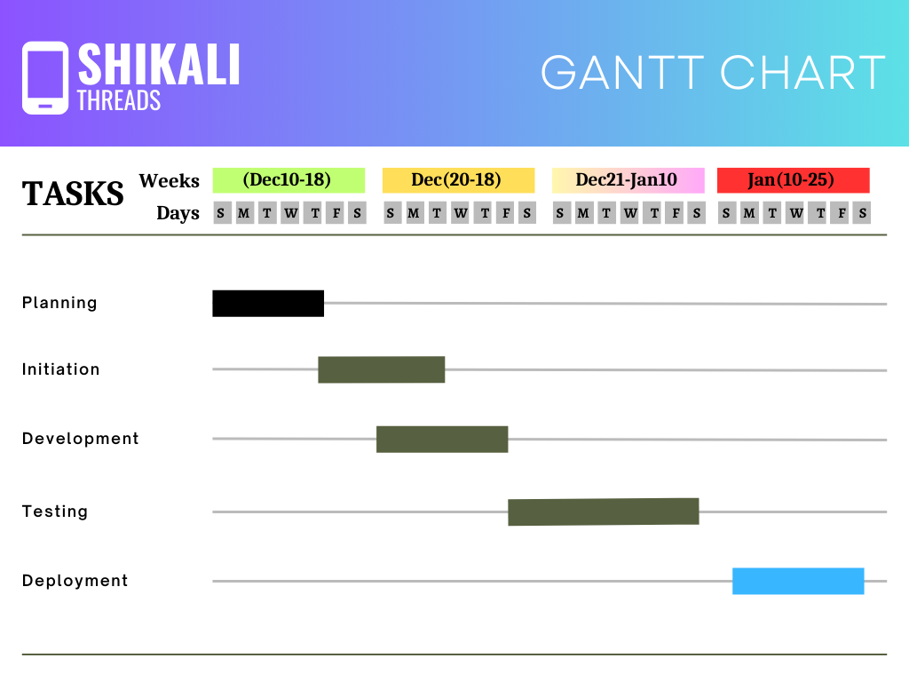

This Gantt chart includes our project overall schedule .

1)Tasks

2)Activities

3)Timeline

4)Duration

5)Dependencies

6)Progress

1. **Market Analysis**

The global market for traditional and ethnic fashion has been growing steadily, driven by increasing interest in cultural diversity, sustainable fashion, and unique, handcrafted products. Shikali Threads is strategically positioned to tap into this growing demand by offering authentic Nepali cultural attire and accessories.

**Target Market**

1. **Local Nepali Communities:** Individuals who value their cultural heritage and seek traditional attire for festivals, weddings, and daily wear.
2. **Diaspora Nepalis:** Nepalis living abroad who wish to stay connected to their roots and purchase traditional garments for cultural events.
3. **Cultural Enthusiasts:** Global customers interested in exploring and owning unique, culturally rich clothing and accessories.
4. **Tourists and Collectors:** Visitors to Nepal and collectors of traditional crafts who appreciate handmade, authentic products.

**Competitor Analysis**

While there are several e-commerce platforms selling ethnic and traditional clothing, Shikali Threads differentiates itself by:

* Focusing exclusively on Nepali cultural attire, offering a curated and authentic collection.
* Highlighting the stories, craftsmanship, and cultural significance behind each product.
* Supporting local artisans and ensuring ethical sourcing practices.

**Market Trends**

1. **Rise of Sustainable Fashion:** Consumers are increasingly prioritizing ethically made, sustainable products, aligning with Shikali Threads’ mission to support local artisans.
2. **Global Interest in Cultural Fashion:** There is a growing appreciation for traditional and ethnic wear as a way to celebrate cultural diversity.
3. **E-Commerce Growth:** The global e-commerce market continues to expand, with more consumers shopping online for convenience and accessibility.

**Opportunities**

* Leveraging digital marketing and social media to reach a global audience.
* Collaborating with cultural organizations and influencers to promote Nepali heritage.
* Expanding product lines to include modern fusion wear inspired by traditional designs.

By understanding these market dynamics, Shikali Threads is well-positioned to carve out a niche in the global e-commerce space while celebrating and preserving Nepal’s rich cultural heritage.

1. **3)Methodologies**

**3.1) Overview**

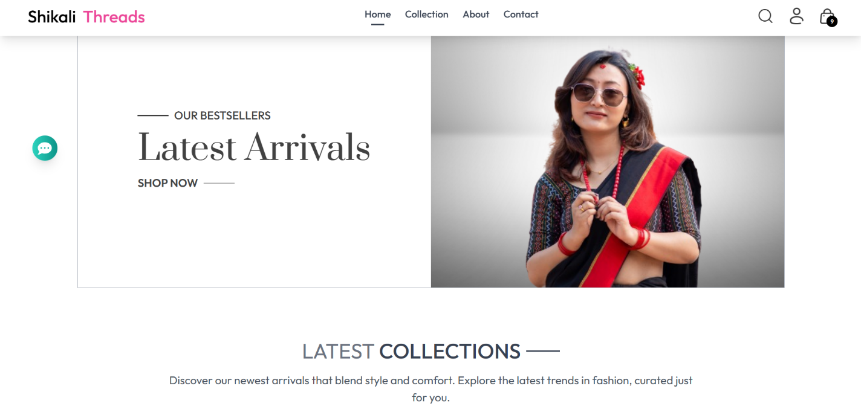

* Registration can be done with signing up with Email , Facebook or phone No .
* There is a search bar where customers can search for the desired product .
* After logging in , users can add the products to the cart and checkout .
* Customers can also track their products .
* ChatBot is also designed for allowing customers to interact when they have doubt regarding the products and any issues .
* For front-end user interface , we used Html,Tailwind css , React js ,Framer-motion.
* For backend user interface, we include the connections between different modules and database connections we have used Node Js , Express Js , MongoDB (database).
* Used Stripe Api, Razor Pay Api for digital payments .
* Images are stored in the cloud resource

**3.2) Technologies used**

Front-end: Html, Tailwind css , Framer-motion , React Js

Back-end : Node Js ,Express Js , MongoDB, Stripe , Razor Pay

HTML: Hyper Text Markup Language is used to create the main structure of a webpage,

which outlines the important components in the webpage which we see.

CSS: Cascading Style Sheets is used to define styles of HTML. All the styles, which we

see on the webpage can be given credit to CSS.

Framer-Motion: Framer Motion is a production-ready motion library for React, designed to create smooth animations, gestures, and interactive UI components with minimal code. It simplifies the process of adding animations to your web applications

ReactJs: ReactJs is a Java Script based front-end web development framework. It is

very useful to create single-page applications. AngularJS was developed by

Meta..

NodeJS: NodeJS is an open-source and cross-platform Java Script run-time environment

which executes JavaScript code server-side.

ExpressJS: It is a web application framework, which is used for NodeJS. ExpressJS can be

used for designing web applications and APIs.

MongoDB: MongoDB is an open-source, cross platform database system. It is a No-SQL

database and uses Java Script Object Notation -like documents with schemas.

Stripe: Stripe is the payment processing API which we used here.

Razor Pay : Razor Pay is the also the alternative payment processing API.

**3.3) Architecture**

* The technologies used to built this e-commerce is MongoDB,ExpressJS ,ReactJs,NodeJs. This stack is popularly called Mern Stack .
* The architectural workflow of MERN stack is as follows:
  + The client makes a request through the **React** frontend application. React handles the user interface and sends the request to the backend.
  + The request is received by **Node.js**, which acts as the backend server. Node.js processes the request and passes it to **Express.js** (a web framework for Node.js).
  + Express.js processes the request and interacts with the database. It sends a query to **MongoDB** (the database) to fetch or manipulate data.
  + MongoDB executes the query, retrieves the required data, and sends it back to Express.js.
  + Express.js receives the data from MongoDB and forwards it to Node.js.
  + Node.js sends the data back to the **React** frontend. React then updates the user interface to display the results dynamically.

The main architecture that lies under this entire flow is Model View Controller , which particularly called MVC architecture .

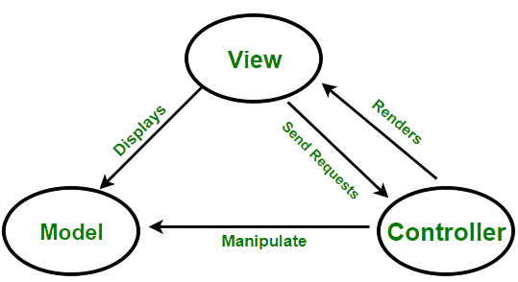

Fig : MVC of MERN

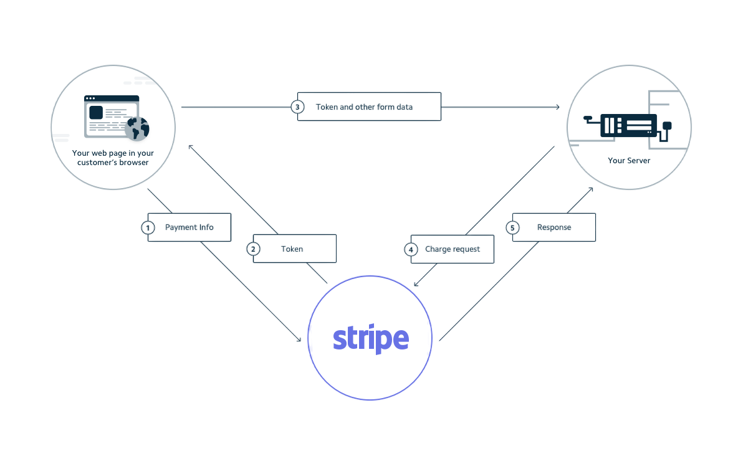

Fig: Backend Stripe Payment

Backend Architecture Workflow

* On the backend part NodeJS sees that all the data is dynamically updated in MongoDB with the help of Express.js.
* Users are authenticated, and only authenticated users can place orders. The users who are authenticated can add items to the cart and checkout.
* At the time of checkout, stripe payment API and Razor Pay payment API is used to make the payment possible.
* NodeJS keeps in contact with MongoDB to update the data dynamically. ExpressJS framework helps NodeJS in achieving this.

**3.4) Features**

1. User Authentication



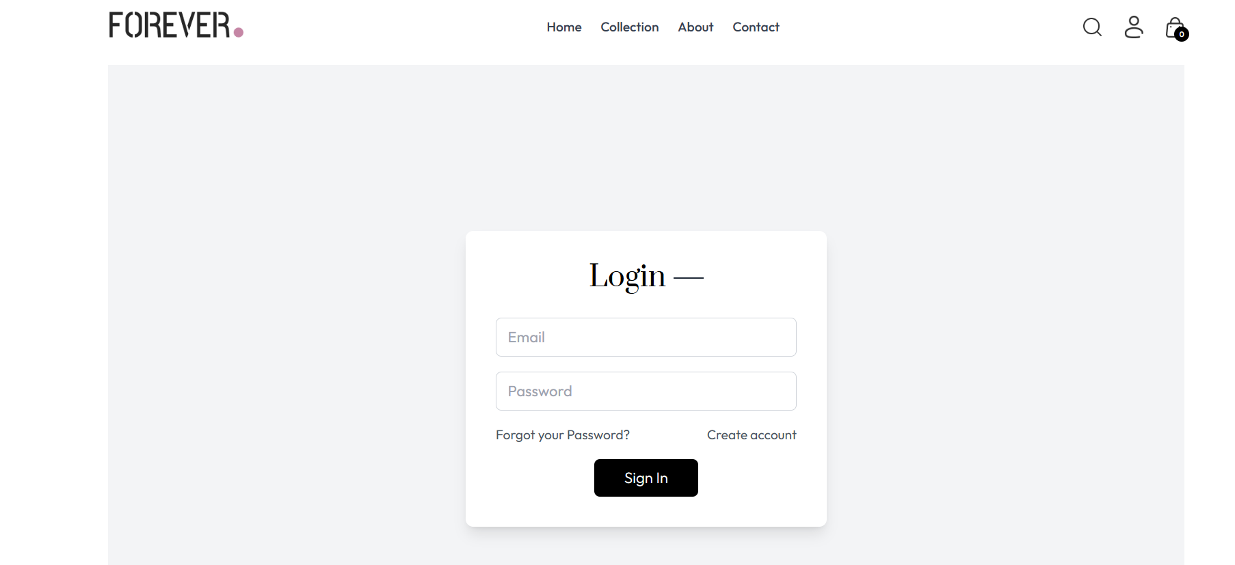

1. Latest Collections

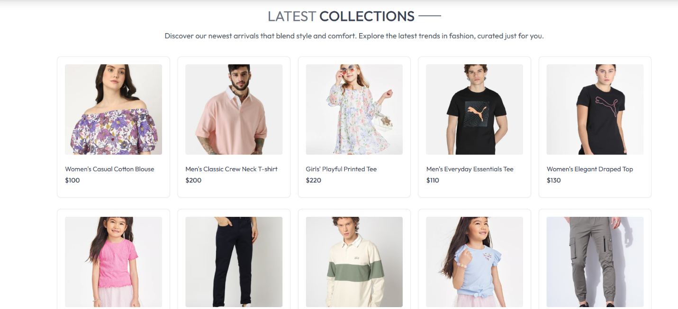

iii. Search Functionality

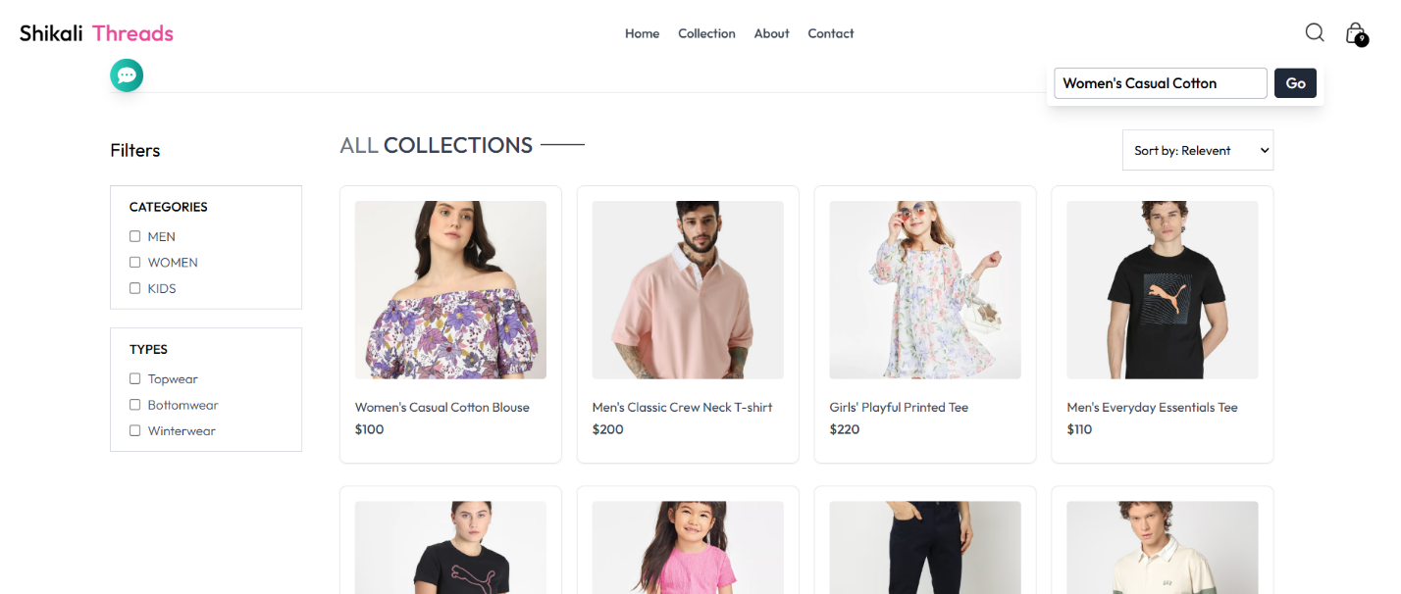iv. Collections

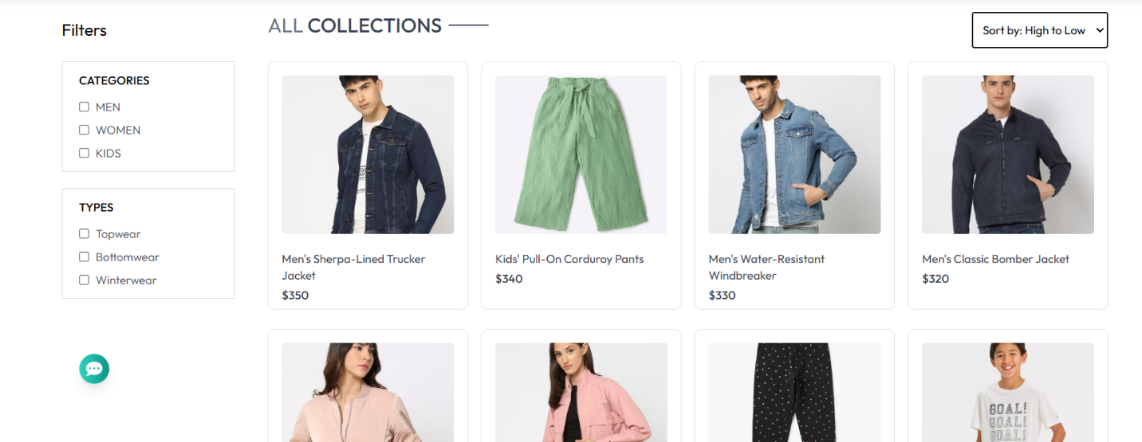

1. Categories

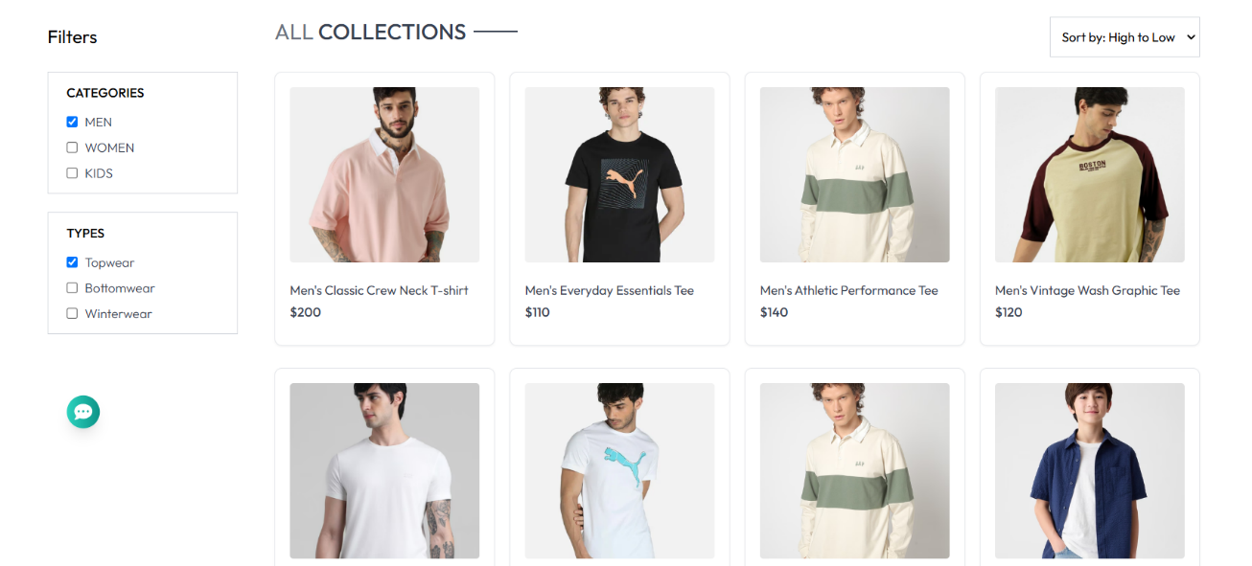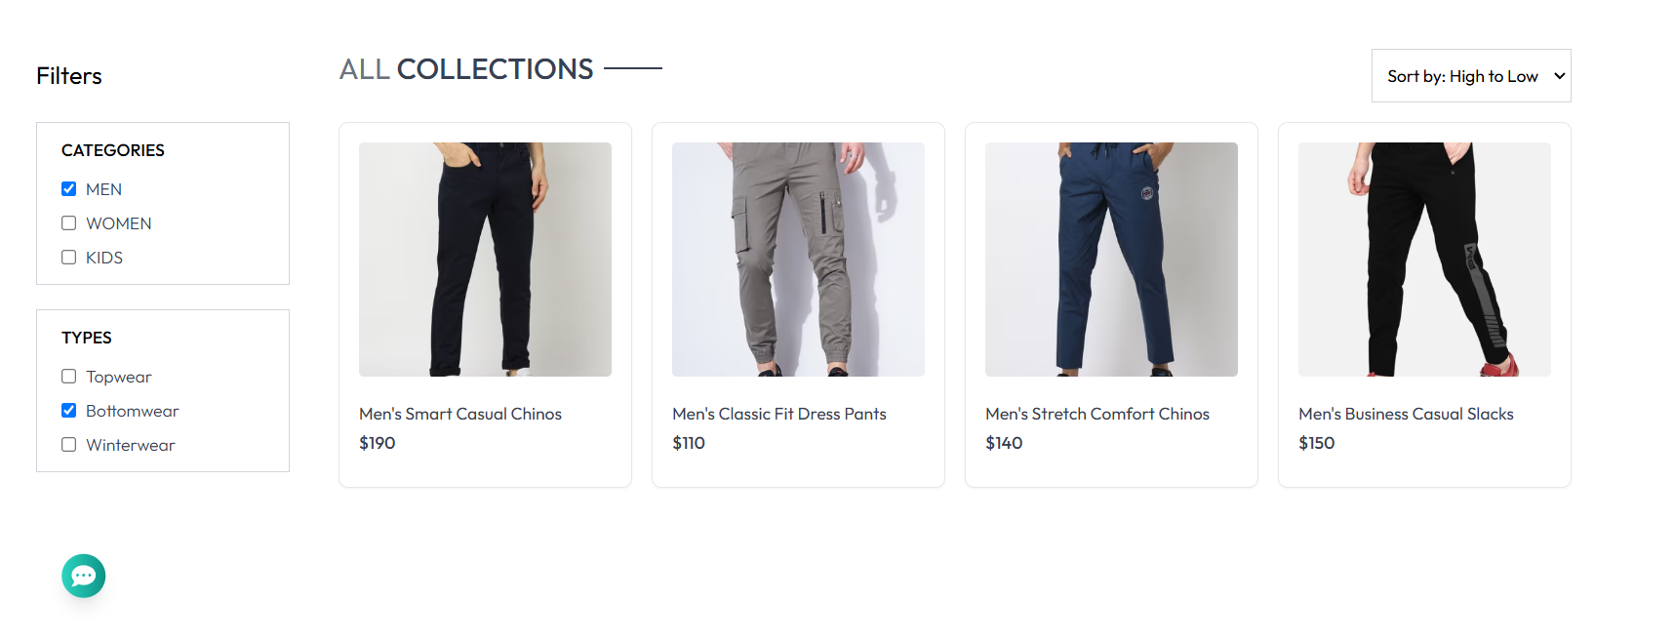

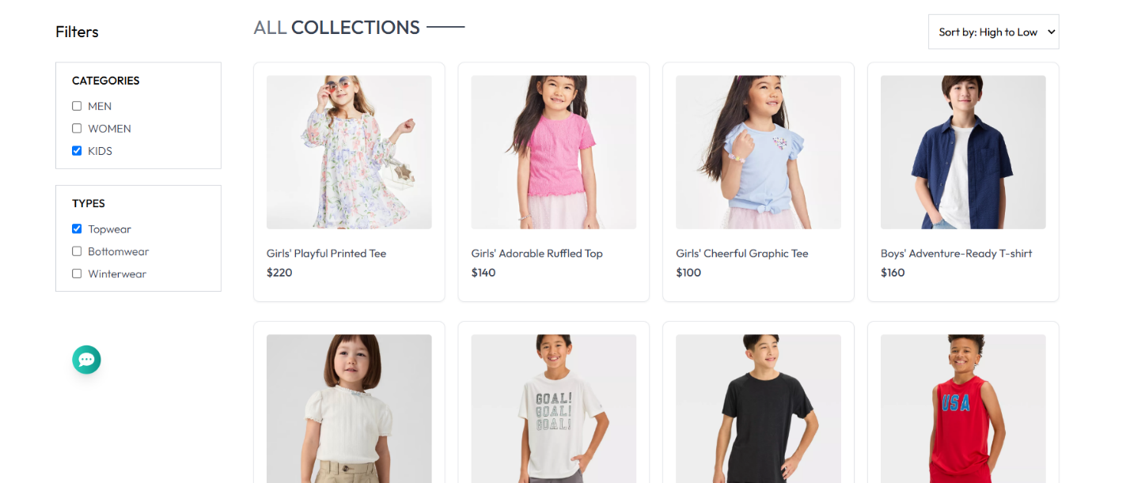

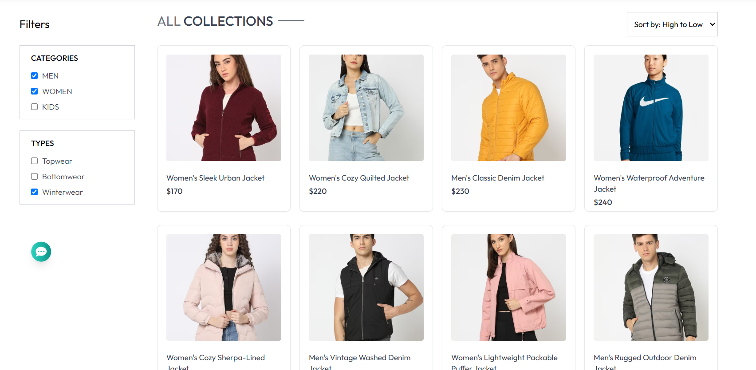



1. Sort Price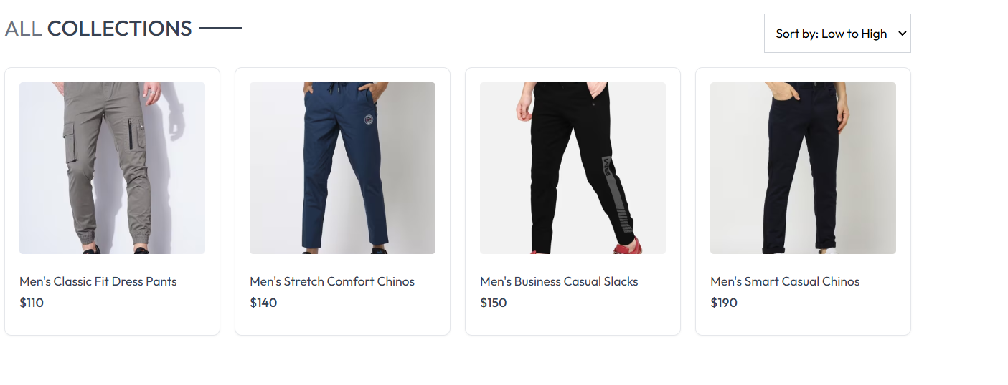
2. Cart

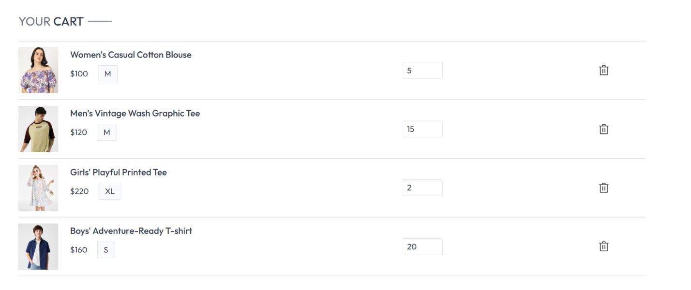

1. Track Orders

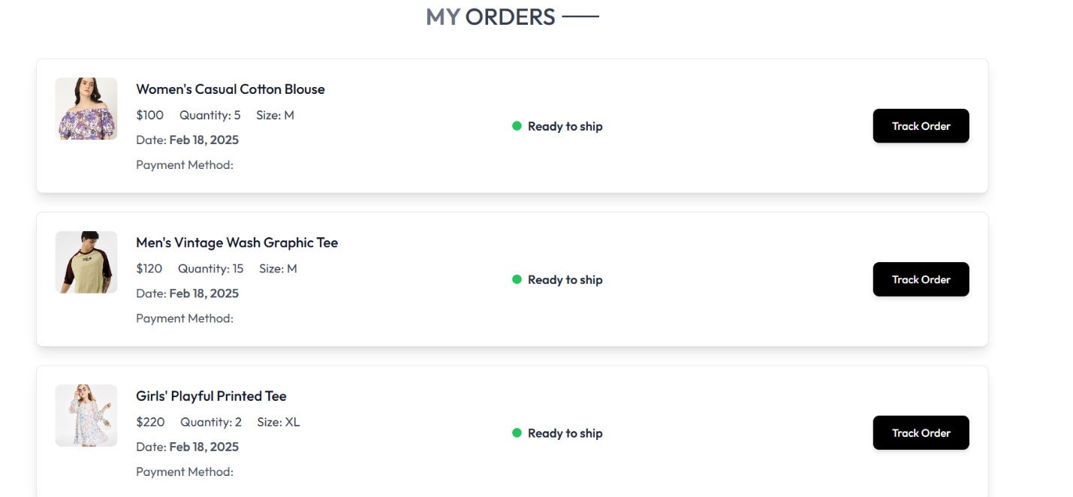

1. Policies

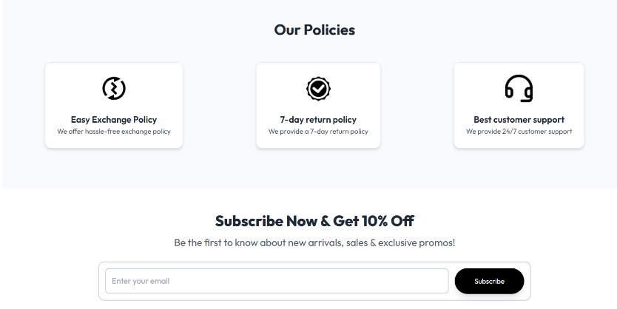

1. About Us

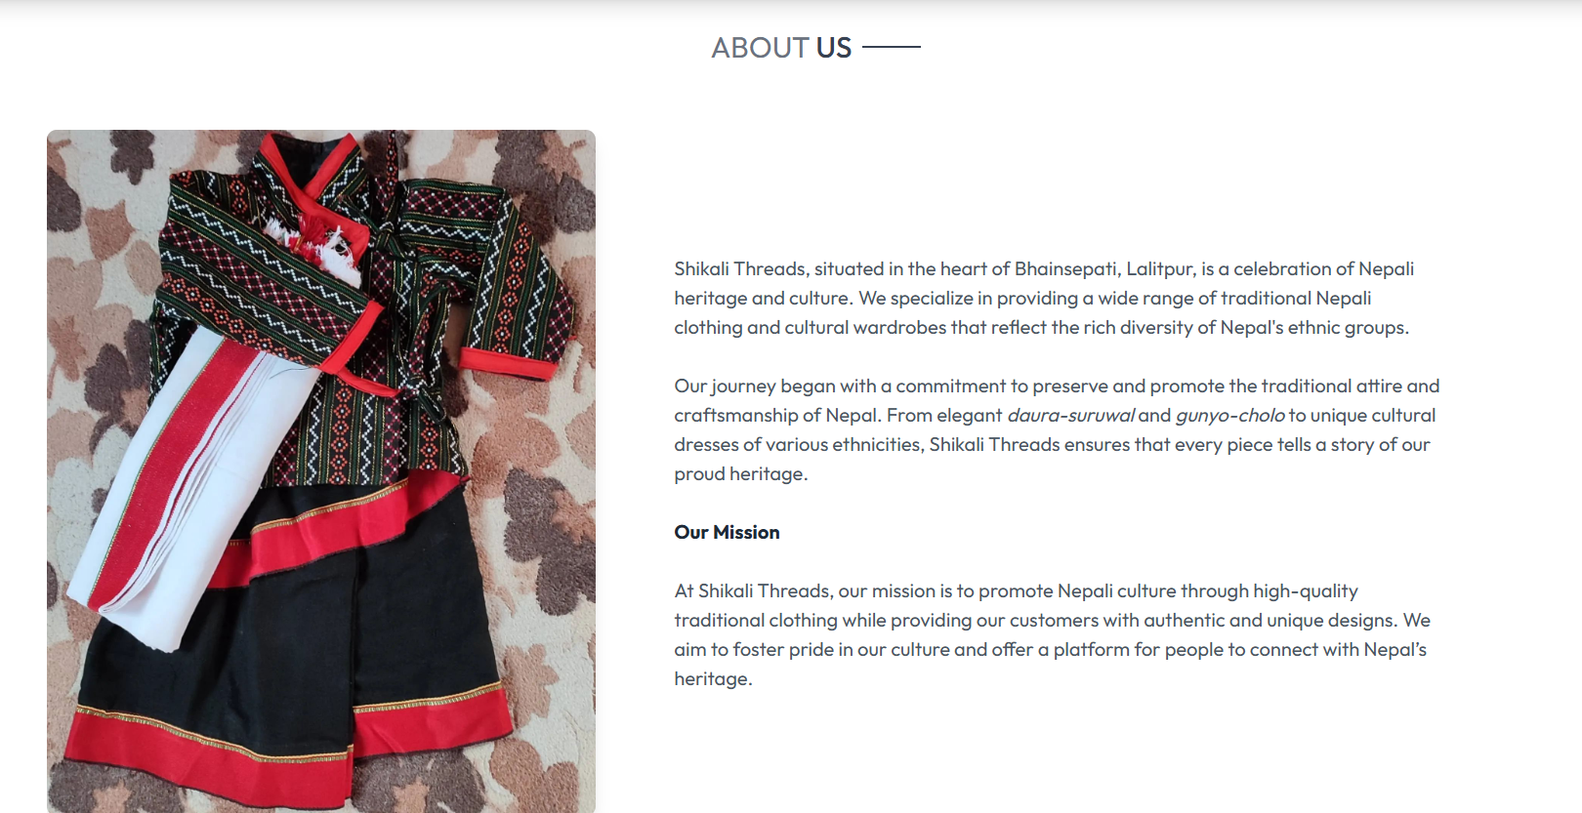

1. Contact

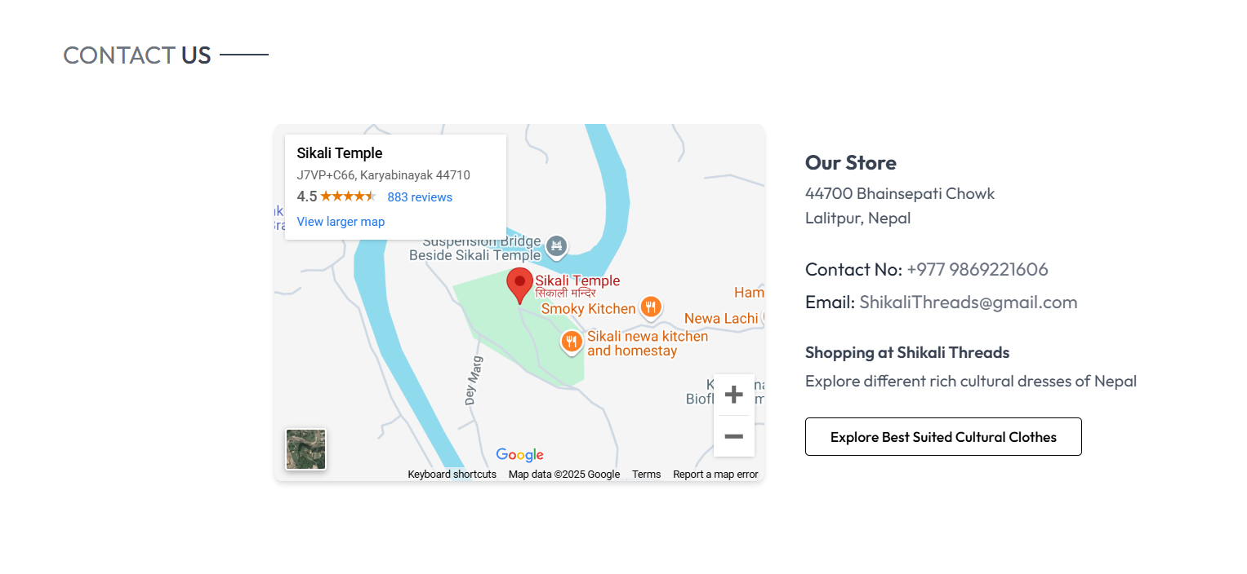

1. ChatBot

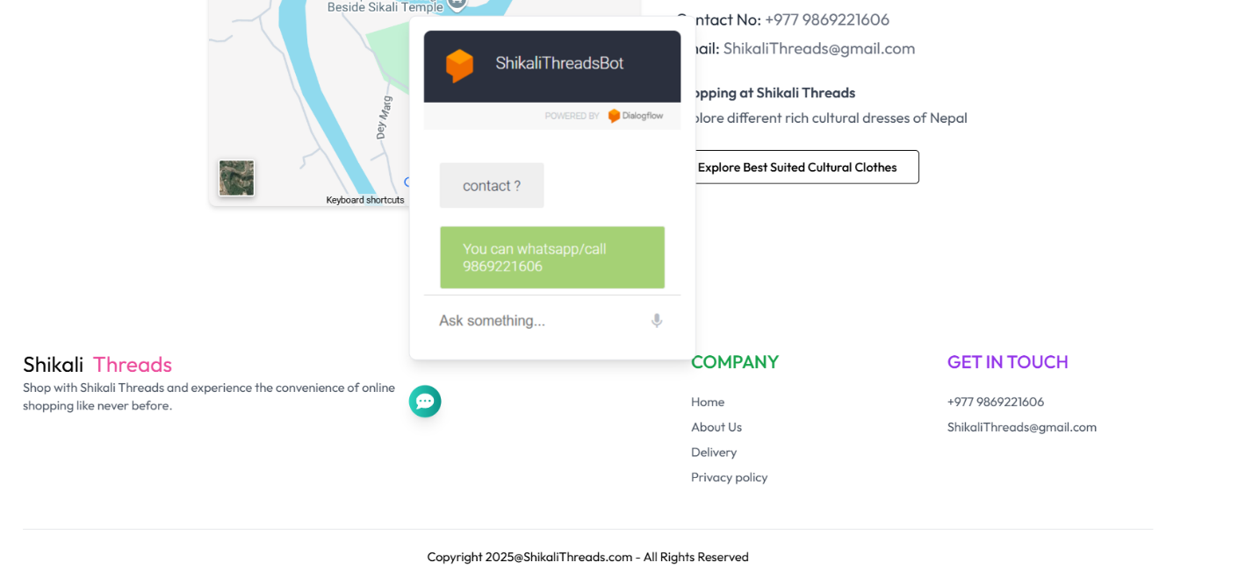

1. **Testing**

Testing is an important phase in order to maintain high-quality standards and deliver a seamless user experience, rigorous testing is essential throughout the development lifecycle.

* 1. **Key Areas of Testing**

1. UI/UX Testing

* **Responsive Design Testing:** Given the integration of Tailwind CSS, it's crucial to ensure that the website looks great across different devices and screen sizes. This includes verifying the behavior of features like the magic cursor, carousel, and cards section, ensuring everything is user-friendly on desktops, tablets, and mobile devices.
* **Cross-Browser Compatibility:** Testing across different browsers (Chrome, Firefox, Safari, Edge) to ensure consistent visual rendering and functionality, especially with interactive elements like the navbar and the contact form.

1. Functional Testing

* Navbar and Navigation Testing : The responsive navbar and sidebar menu should be tested thoroughly for both large and small screens. Navigation links should be properly routed using react-router-dom, and any animations (such as the scrolling color change) should be smooth and error-free
* **Product Pages & Cart System:** Testing the product catalog, details page, and shopping cart functionality to ensure that products can be added, viewed, and removed correctly. For checkout processes, form validation and submission (including payment) need to be verified.
* **Form Validation:** Testing the client-side validation for forms (e.g., contact form and user registration/login forms). This includes ensuring that empty or incorrect inputs trigger appropriate error messages and that data is correctly handled when submitted.

1. Performance Testing

* **Load Testing:** Simulating heavy traffic to see how well the MERN stack handles multiple users browsing products or completing orders simultaneously.
* **Speed and Optimization:** Testing the speed of loading product pages, images, and other dynamic elements like the carousel, ensuring that React components and animations (like those using Framer Motion) don't cause delays.

1. Security Testing

* **Data Protection:** Ensuring that sensitive data such as payment details and user information is securely stored and transmitted. The backend API (Node.js and Express) should be tested for security vulnerabilities such as SQL injection and cross-site scripting (XSS).
* **Authentication and Authorization:** Verifying that user authentication (using tools like JWT) is correctly implemented, ensuring that only authenticated users can access certain areas (like the user account or checkout pages).

1. Integration Testing

* **Frontend and Backend Integration:** Testing how React components interact with the Node.js backend. This includes verifying that the user actions on the frontend (e.g., adding products to the cart or submitting an order) are correctly processed by the backend and MongoDB database.
* **External Services:** Verifying the integration of third-party services like payment gateways (Stripe, PayPal) and email services (for order confirmation and newsletters)

1. Unit and Component Testing

* **Unit Tests for Backend Logic:** Testing individual backend services and APIs that handle business logic, such as managing the product catalog, processing orders, and handling user authentication.
* **React Component Testing:** Unit tests for React components to ensure they render correctly and handle interactions (like form submissions or clicks) properly. Tools like Jest and React Testing Library are useful here.

1. End-to-End Testing:

* **User Flow Testing:** Simulating real user scenarios, such as browsing through product listings, adding items to the cart, and proceeding to checkout. This ensures that the entire purchase flow is smooth and functioning properly from start to finish.



1. **Deployment**

**5.1) FrontEnd Deployment on Vercel :**

* **React Application:** The frontend of Shikali Threads was deployed using Vercel's seamless integration with GitHub. The build process optimizes the React app and serves it as static assets, ensuring fast load times and smooth interactions.
* **Automatic Deployment:** Vercel automatically deployed the app whenever changes were pushed to the GitHub repository, ensuring the latest version of the frontend is live. Every update was tested through Vercel’s preview deployments, which allowed for review before going live.

**5.2) BackEnd Deployment :**

* **Serverless Functions:** The backend of Shikali Threads is deployed as serverless functions on Vercel. These functions handle API requests (such as product listings, cart management, and user authentication) without the need for managing a traditional server.
* **Environment Variables:** Sensitive data, such as the MONGO_URI for the MongoDB database and JWT_SECRET for secure authentication, was securely stored in Vercel's environment variable settings. This ensures safe and encrypted management of API keys and database credentials.

5**.3) Database Deployment**

* **MongoDB Atlas:** The database for Shikali Threads is hosted on **MongoDB Atlas**, a fully managed cloud database service. The connection string is securely stored in the Vercel environment variables, ensuring a secure link between the deployed app and the database.

Conclusion :

Shikali Threads was successfully deployed on **Vercel**, taking full advantage of Vercel’s serverless functions, automatic scaling, and seamless integration with GitHub. With robust performance monitoring, easy updates, and secure deployment, Vercel provided the ideal environment for hosting a MERN stack application.

1. **Future Scope**

As the platform grows, there are numerous opportunities to expand its features, enhance user experience, and scale operations. The future scope of Shikali Threads lies in its potential for technological improvements, business growth, and market expansion.

Key Areas for Future Development

1. Advanced Personalization:

* **AI-Powered Recommendations:** Implementing machine learning algorithms to offer personalized product recommendations based on user preferences, browsing history, and past purchases. This will enhance the customer experience and drive sales.
* **Personalized Marketing:** Use AI-driven marketing strategies like personalized email campaigns and targeted advertisements based on user behavior, increasing customer engagement and conversion rates.

1. Augmented Reality (AR) Integration:

* **Virtual Product Try-Ons:** Implementing augmented reality (AR) features that allow customers to visualize how products (e.g., photo-holding frames) will look in their home environment. This can significantly enhance the shopping experience, especially for decor-related products
* **AR-based Customization:** Providing customers with the ability to visualize customizations (e.g., temple architecture modifications or frame colors) in real-time before making a purchase.

1. Mobile App Development:

* **Native Mobile App:** Developing a dedicated mobile app for both **iOS** and **Android** to offer a more seamless, optimized shopping experience on mobile devices. The app could include push notifications for offers, order tracking, and faster checkouts.
* **Progressive Web App (PWA):** As an alternative, Shikali Threads could implement a Progressive Web App (PWA) for users who prefer not to install an app. PWAs provide a mobile-like experience in a web browser with offline capabilities

1. Subscription and Loyalty Programs:

* **Subscription Models:** Introducing subscription services, where customers can sign up for regular deliveries of new or popular items (e.g., monthly updates of new temple architecture designs or frame styles).
* **Loyalty Program:** Launching a loyalty program that rewards customers with points, discounts, or exclusive access to new products based on their purchase history and engagement on the platform.

1. Internationalization and Market Expansion:

* **Multi-Language Support:** Expanding the platform's reach by introducing multi-language support, allowing users from different linguistic backgrounds to engage with the platform easily.
* **Global Shipping:** Implementing global shipping options to expand the customer base beyond the current region, ensuring the platform is accessible to international customers.
* **Localized Payment Gateways:** Integrating payment systems that cater to different regions, offering localized payment methods such as PayPal, Stripe, or region-specific credit cards.

1. Enhanced Backend Features:

* **Order Management System (OMS):** Developing a more robust order management system to track, manage, and process customer orders efficiently, ensuring timely deliveries and inventory management.
* **AI-powered Inventory Management:** Using AI and predictive analytics to optimize inventory levels and reduce stock-outs or overstock situations. This will help in improving supply chain efficiency and customer satisfaction.

1. Sustainability Initiatives:

* **Eco-Friendly Products:** Introducing more eco-friendly or sustainable products to align with growing consumer preferences for environmentally responsible brands.
* **Carbon Footprint Tracking:** Implementing features that allow customers to track the carbon footprint of their purchases and offering incentives for choosing eco-friendly shipping or products.

1. Integration with Social Media and Marketplaces:

* **Social Media Integration:** Creating direct shopping experiences through social media platforms like Instagram, Facebook, and Pinterest, enabling users to purchase directly from social media posts or ads.
* **Marketplaces Integration:** Expanding into third-party marketplaces like Amazon or Etsy to reach a larger audience and increase brand exposure.

1. **Conclusion**

Shikali Threads has successfully established itself as a unique e-commerce platform that blends traditional craftsmanship with modern technology. With its focus on offering meticulously crafted small temple architectures, photo-holding frames, and related products, it serves as a bridge between cultural heritage and contemporary consumer needs.

As the platform continues to evolve, the future holds vast potential for further expansion, innovation, and customer engagement. Leveraging advancements in artificial intelligence, augmented reality, and mobile technology will enhance the shopping experience, offering personalized and immersive interactions.

Expanding into global markets and integrating sustainable practices will not only elevate the brand but also help build a loyal, eco-conscious customer base.

By staying committed to its mission of providing high-quality, authentic products, and continuously improving its technological and operational capabilities, Shikali Threads is poised to become a trailblazer in the niche e-commerce space. As the platform grows, it will not only meet the demands of a rapidly changing market but also enrich the lives of customers, bringing culture, art, and functionality into their homes.

In conclusion, Shikali Threads is just beginning its journey, with an exciting future ahead as it embraces new opportunities and innovations, positioning itself as a leader in the e-commerce industry.